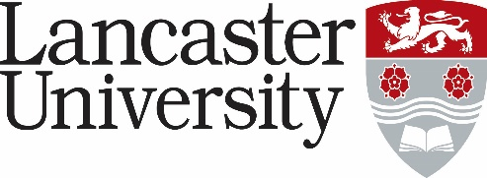

**PERSON SPECIFICATION**

**Research Associate in Victorian Cultural and Material History**

**Vacancy Ref: 1263-24**

|  |  |  |
| --- | --- | --- |
| **Criteria** | **Essential/ Desirable** | **\* Application Form/ Supporting Statements/ Interview** |
| Possess a PhD (or equivalent) in History or a related research area | Essential | Application Form / Supporting Statement |
| Capable of carrying out UK-wide research independently and under direction as part of a team | Essential | Application Form / Supporting Statement |
| Demonstrate an ability to work collaboratively and flexibly with colleagues | Essential | Supporting Statement / Interview |
| Proven experience in archive-based historical research in national and local repositories | Essential | Application Form / Supporting Statement / Interview |
| Experience of transcribing and processing nineteenth-century documents, including manuscript sources | Essential | Application Form / Supporting Statement / Interview |
| Experience of working with online digital repositories, including periodicals and museums databases | Essential | Application Form / Supporting Statement |
| Ability to analyse a range of different historical materials including textual, visual, and material sources | Essential | Application Form / Supporting Statement / Interview |
| Demonstrable efficient time management and organisation skills | Essential | Application Form / Supporting Statement / Interview |
| Has skills and/or experience of the following:   * NVivo or equivalent qualitative research software * Excel/ Google Sheets * Omeka-S or other web-publishing platform | Desirable | Supporting Statement / Interview |
| Experience in publishing or ability to write research outputs individually and/or collaboratively | Desirable | Application Form / Supporting Statement / Interview |
| Ability to present their work to academic and non-specialist audiences, including at work meetings and conferences | Desirable | Supporting Statement / Interview |
| Experience of organising academic research or engagement activities, e.g., conferences, workshops, talks, exhibitions | Desirable | Supporting Statement / Interview |
| Experience in researching the Victorian body and / or material culture | Desirable | Supporting Statement / Interview |

* **Application Form** – assessed against the application form, curriculum vitae and letter of support. Applicants will not be asked to answer a specific supporting statement. Normally used to evaluate factual evidence e.g., award of a qualification. Will be “scored” as part of the shortlisting process.
* **Supporting Statements** - applicants are asked to provide a statement to demonstrate how they meet the criteria. The response will be “scored” as part of the shortlisting process.
* **Interview** – assessed during the interview process by either competency-based interview questions, tests, presentation etc.